Testbench Output Annotations

Song Reader
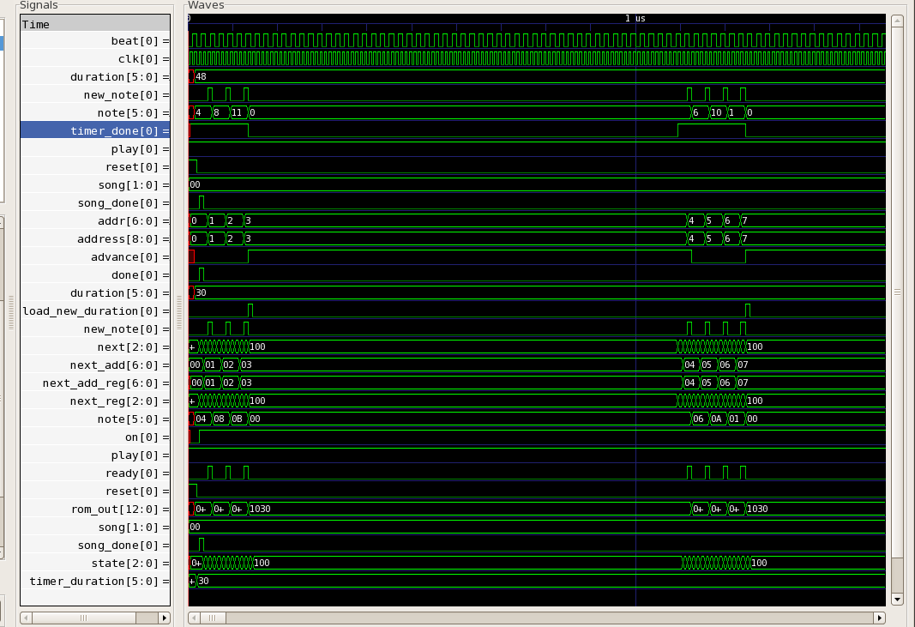

Reads in three notes and waits the correct amount of time before reading the next three notes.

Music player/harmonics
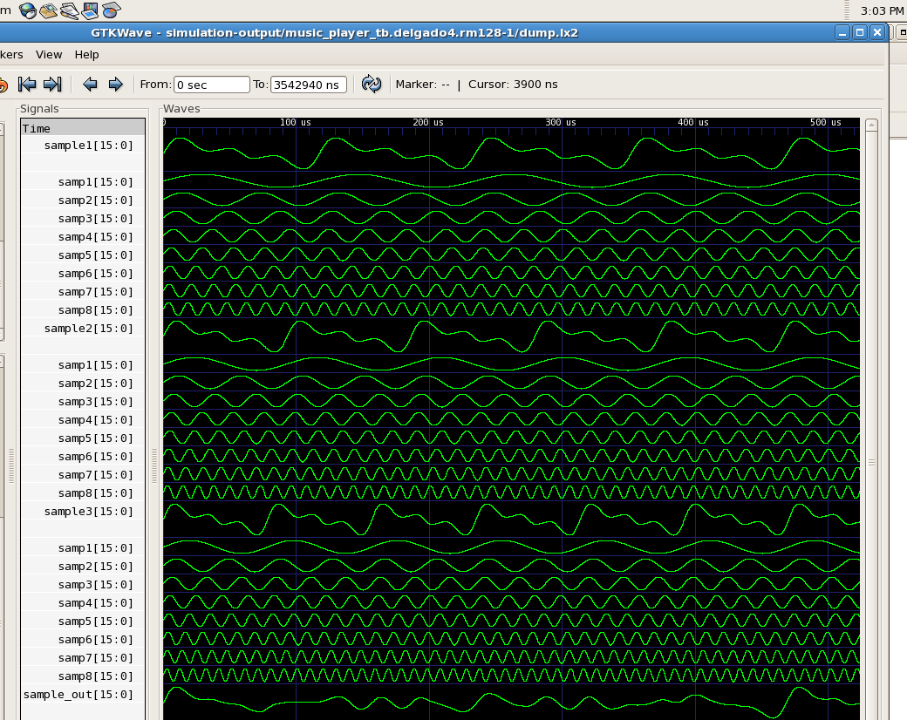

The harmonic breakdown of three notes being played at the same time, followed by the summation of those three notes (or of the 24 harmonics).

Chords
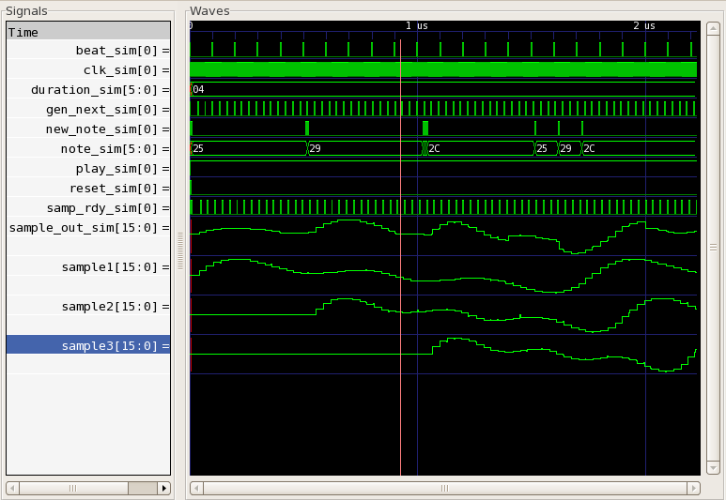
We read in three notes, the summation of which is sample_out_sim.

Dynamics_calc
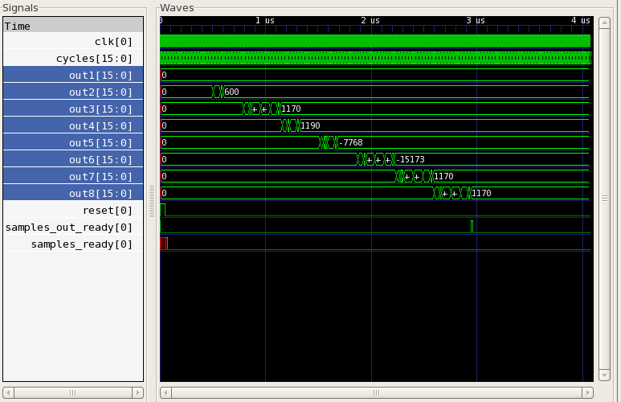
Over time, this module determines the correct outputs for given inputs.
Midi_harmonic_dynamics
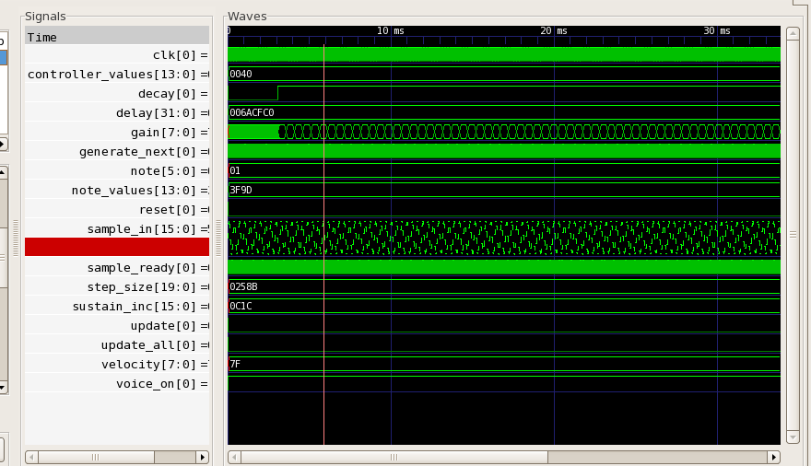
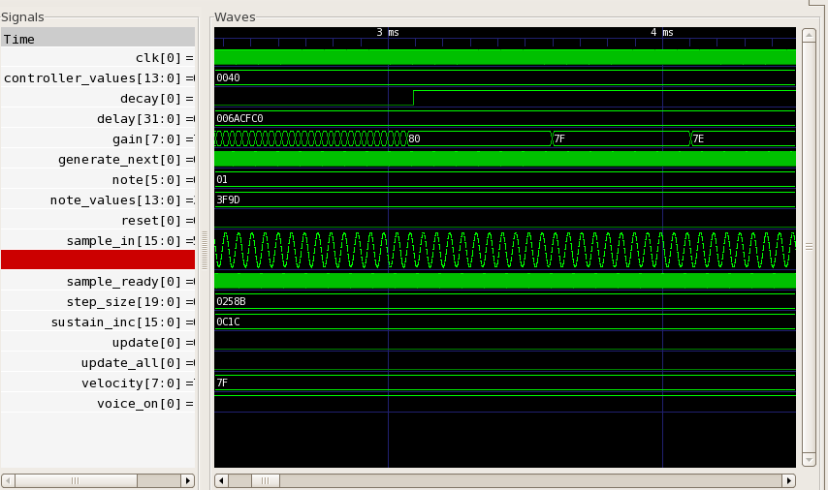
For a given note, gain increases from 0 to 0x80 and then decreases to zero (eventually).

Midi_message_capture
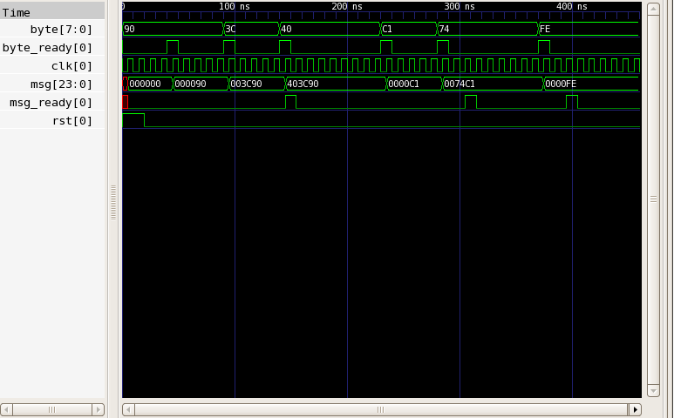
Mimics receiving data bytes over the rs232 interface. Assembles a three-byte (or fewer, depending on the midi command byte) message from successive inputs.

Midi_message_handler
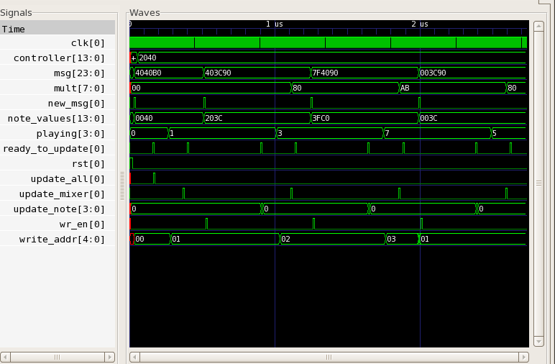
Midi messages are received and the corresponding system control outputs (mult, new_msg, etc.) are set. For example:
4040B0:
controller output set (2040)
new_msg set to 1’b1 for one cycle
wait for ready_to_update
set update_all to 1’b1 for one cycle
etc.

Midi_note_reg
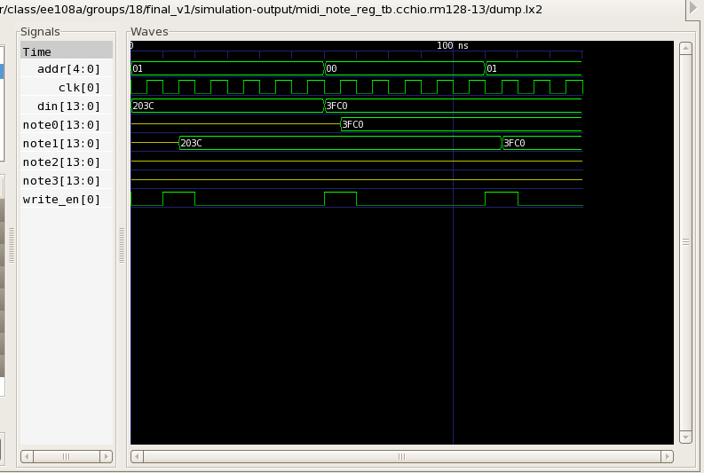
Tests that the correct addresses are written and that values written are output on the correct output. (the unconnected signals are expected)

Midi_note
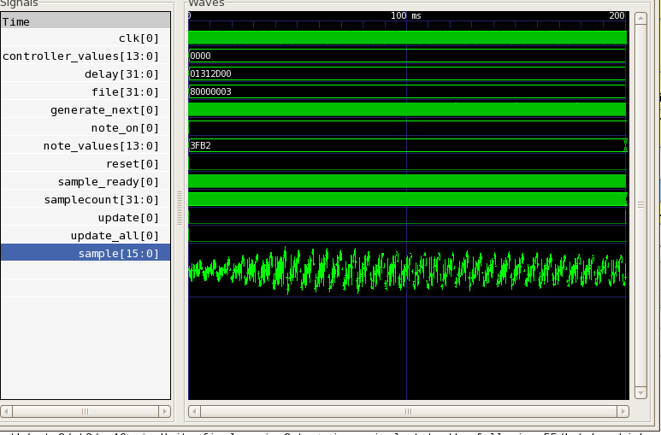
One second of sound output with harmonics and dynamics

Midi_wave_reader
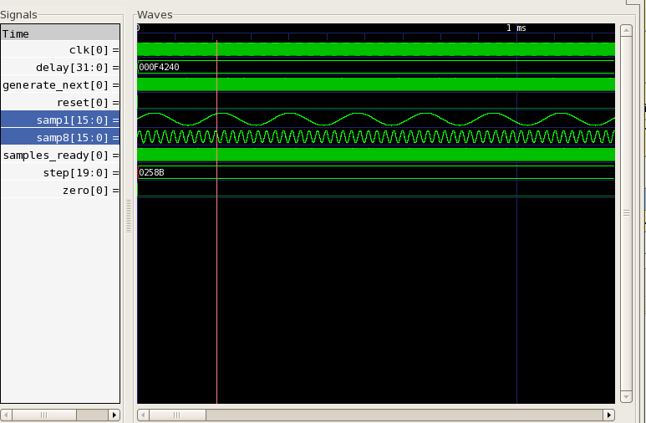
Tests producing two sine waves (1st and 8th harmonic)

Next_midi_note
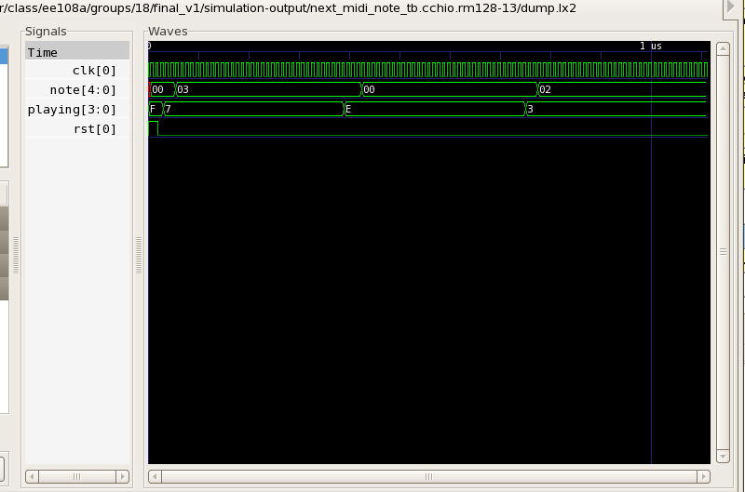
Changes the notes that are currently playing and confirms that note is set to the index of the first open note.

Pipelined_scaler
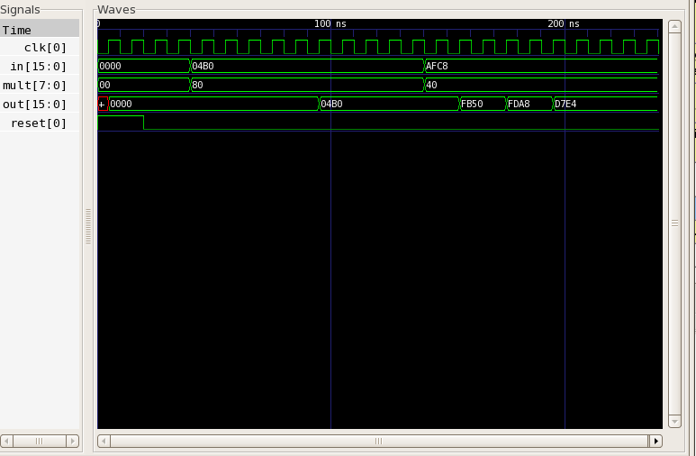
Changes inputs and confirms that the output is set to the correct output after six clock cycles.

Polyphony_mixer
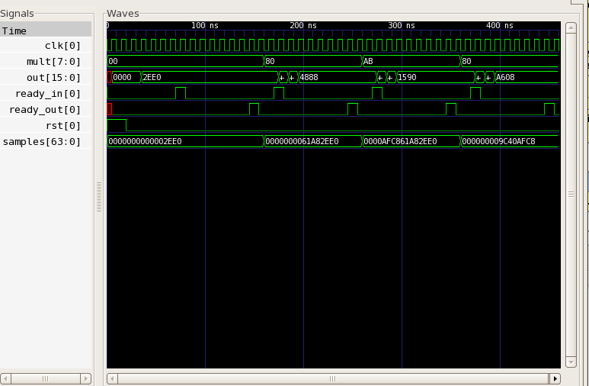
Changes the input samples and the multiplier and checks that the mixer outputs the correct mix value.

RS232
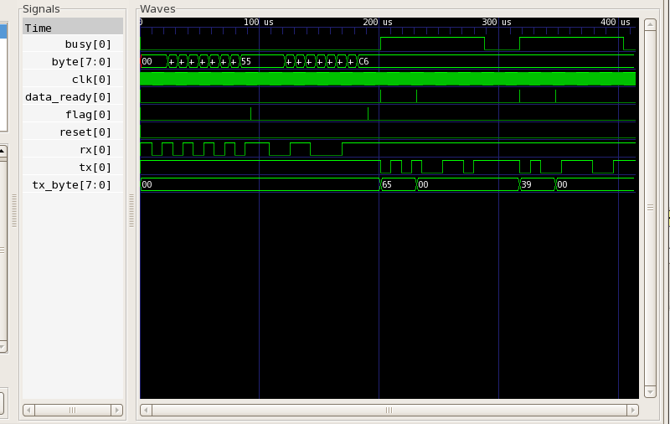
First models the receipt of multiple bytes by transitioning the rx pin, and then transmits multiple bytes over the tx pin.

Sustain_variation
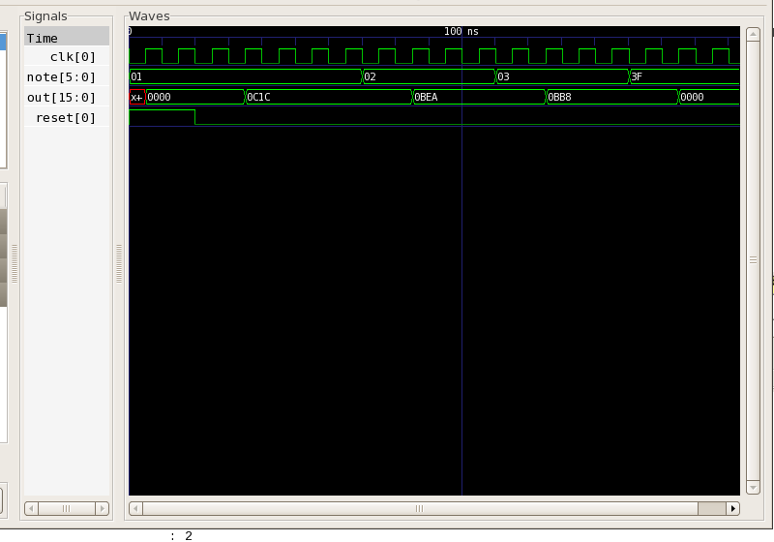
Changes the input note and confirms the value of out.

*The sound file from the midi_dynamics testbench is also included. It demos one second of audio with harmonics and dynamics.

